**Hithesh Shanmugam**

**CSC 481**

**Assignment-5 Resubmission**

**Assignment-5 wrong parts:**

Question 2

Part b and c there was only one segment

**Question 2 Part b:**

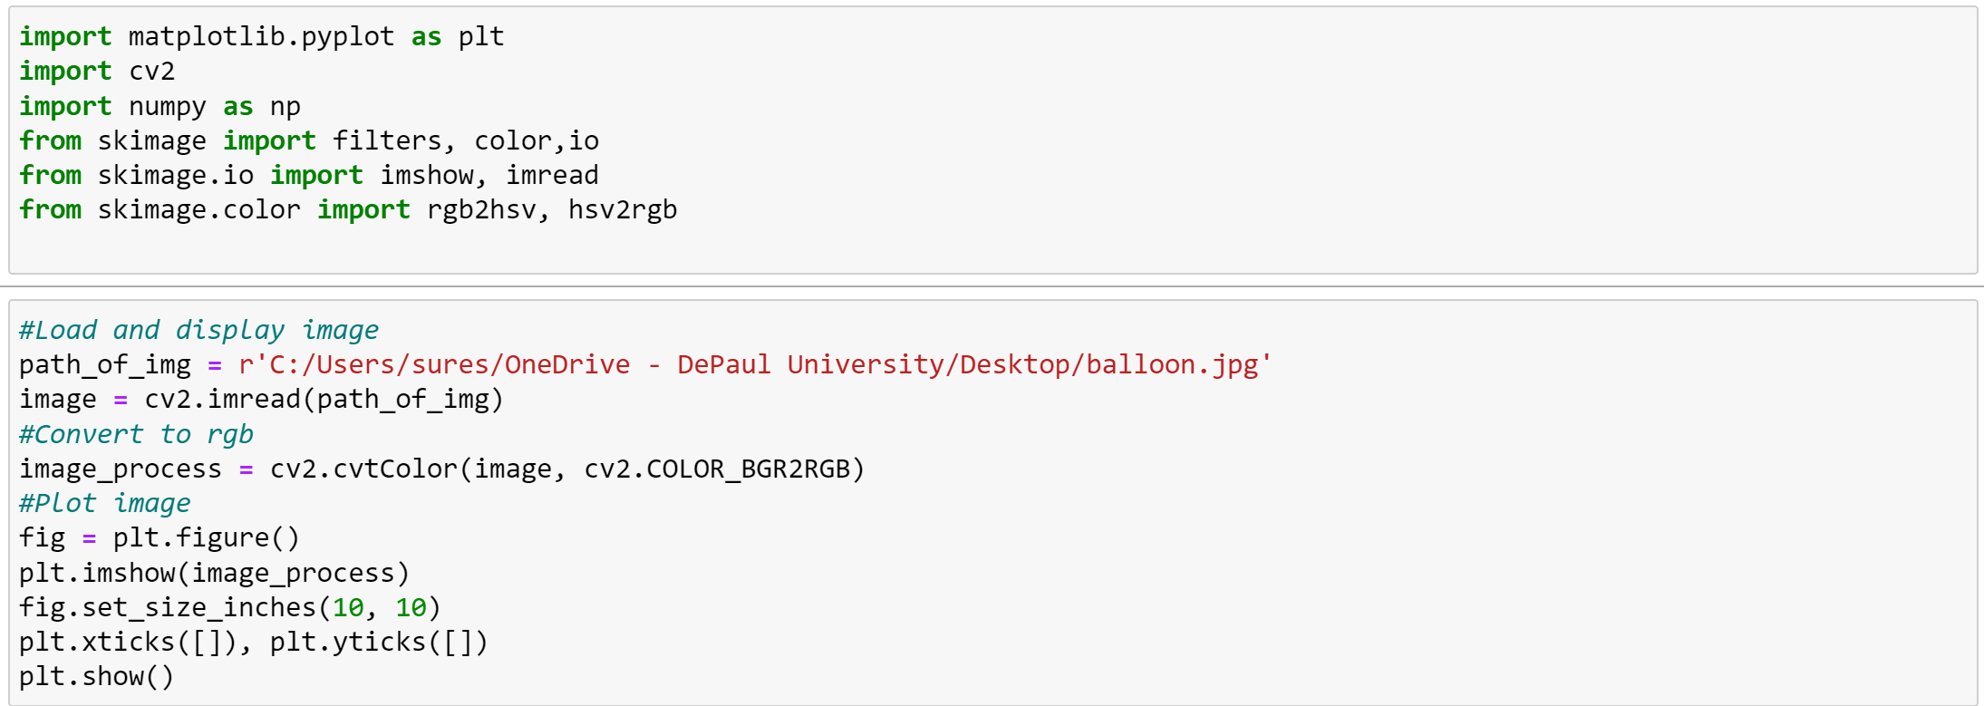

**Output:**

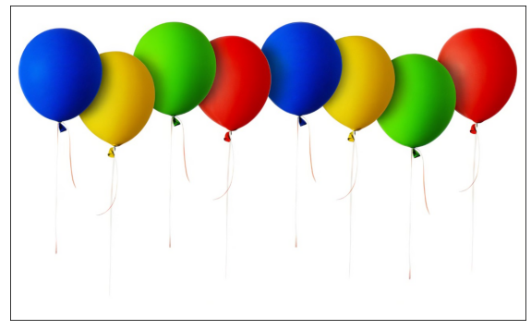

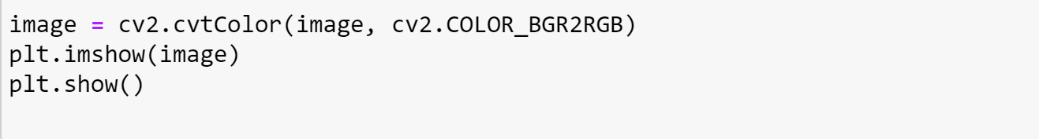

**Output:**

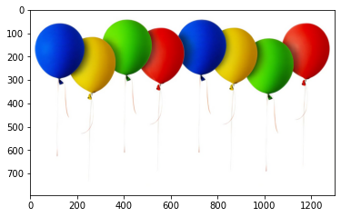

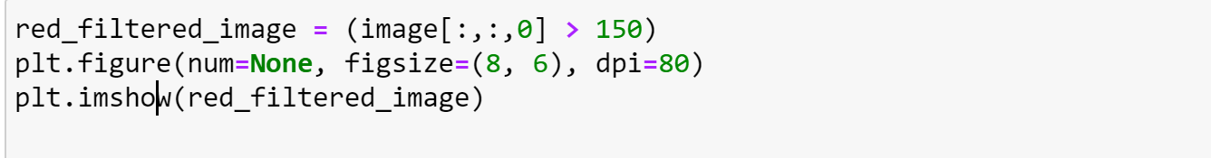

**Output:**

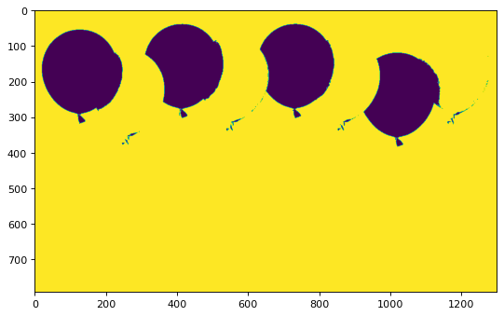

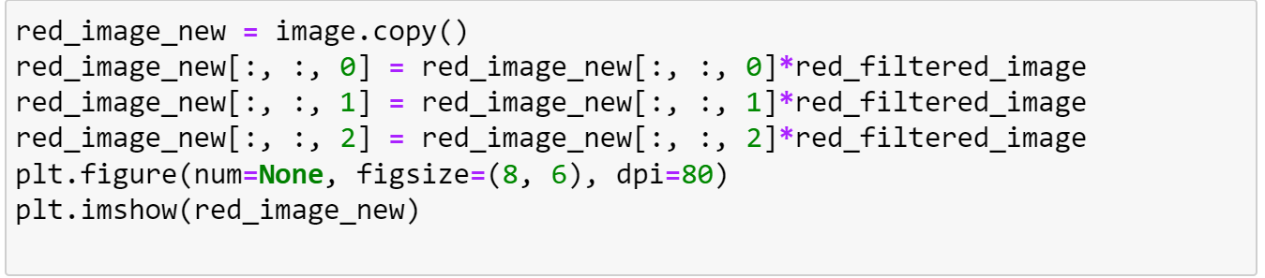

**Output:**

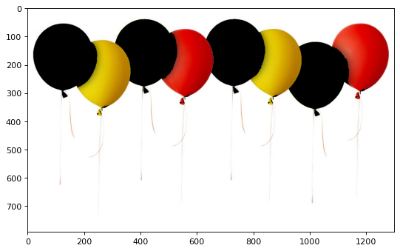

The yellow pixels are mixture of the red and green pixels so they are visible here.

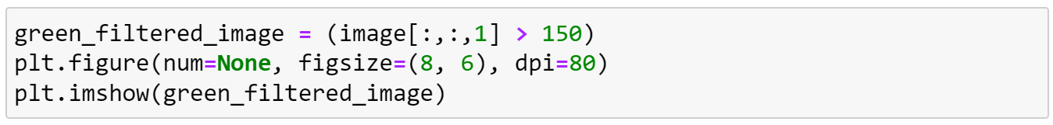

**Output:**

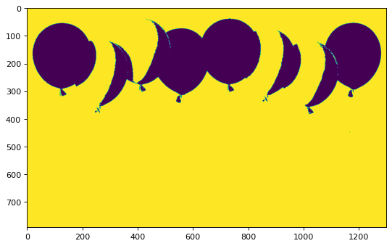

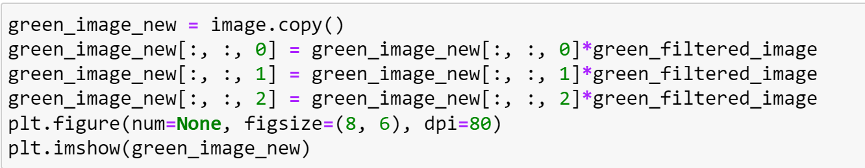

**Output:**

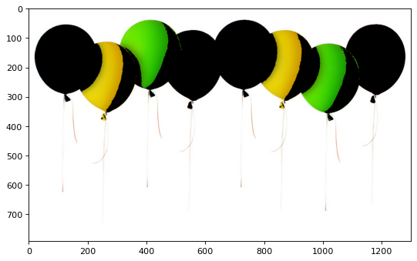

Same goes for the green filtering here the yellow pixles are visibe in the green filtering.

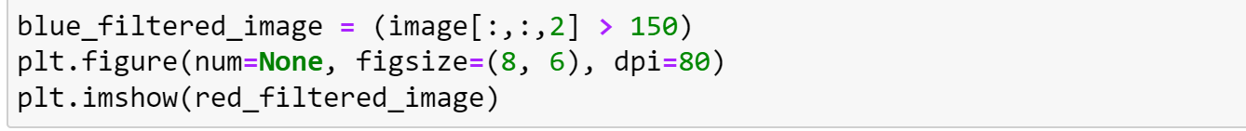

**Output:**



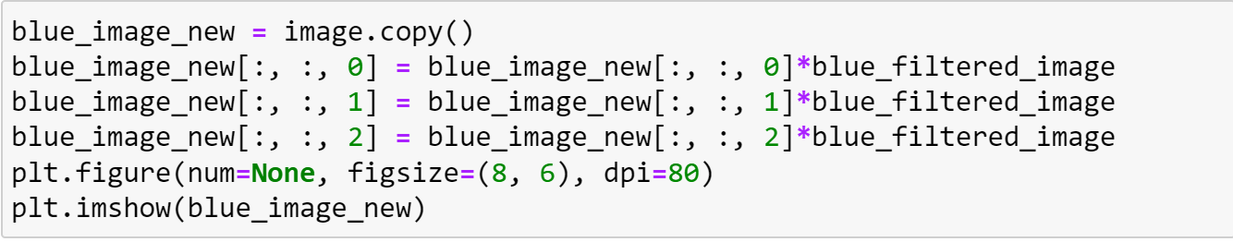

**Output:**

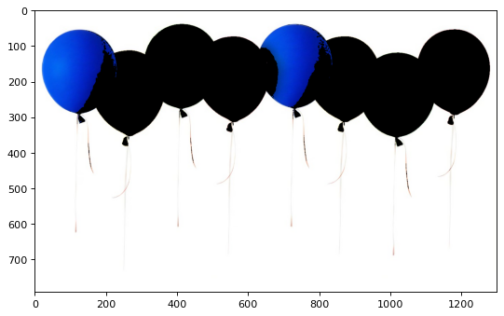

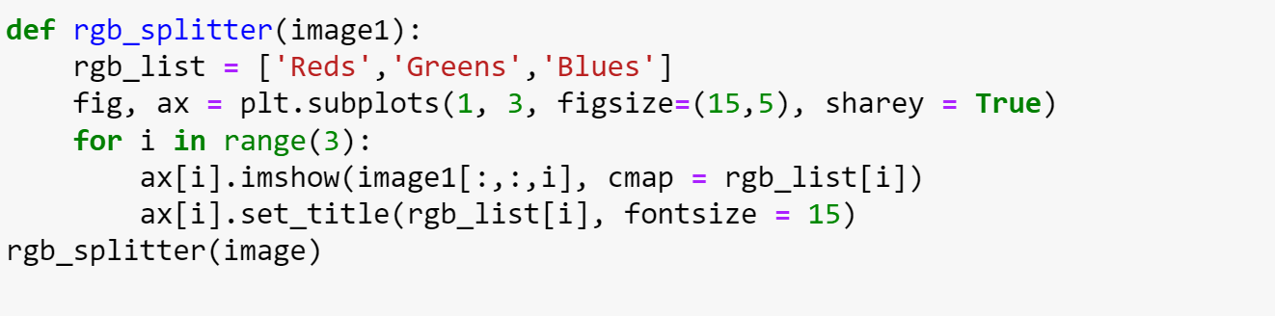

**Output:**

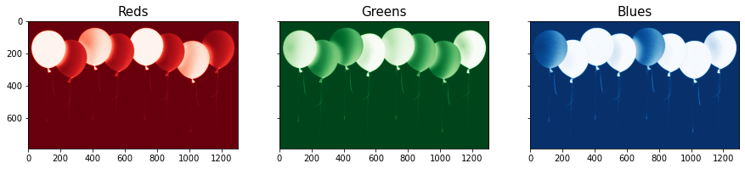

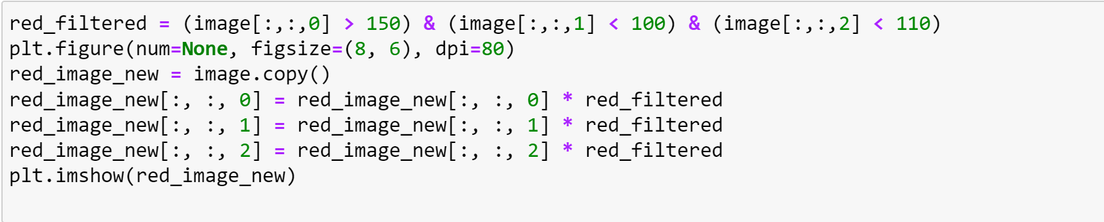

**Output:**

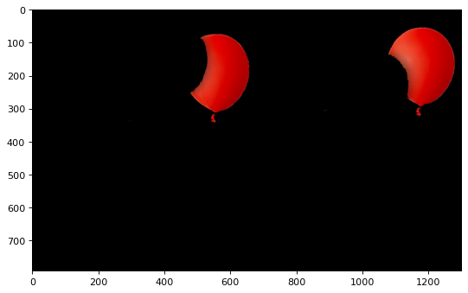

To avoid the yellow pixels the other channels are also thresholded here so that the red pixels are clearly visible.

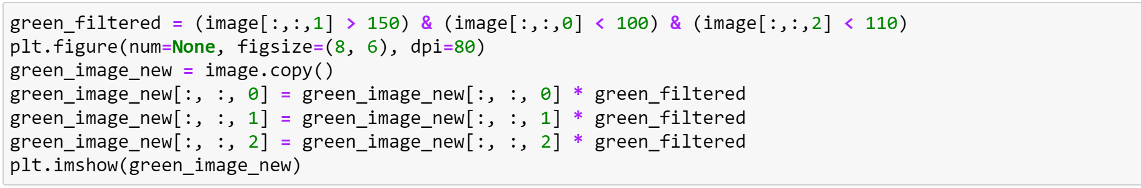

**Output:**

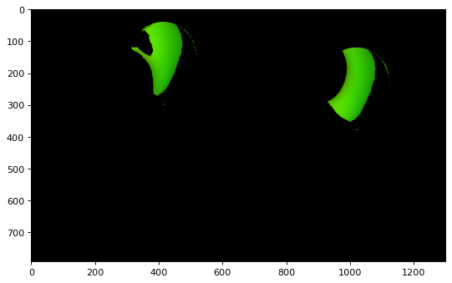

The same thresholding is applied here to view only the green pixels.

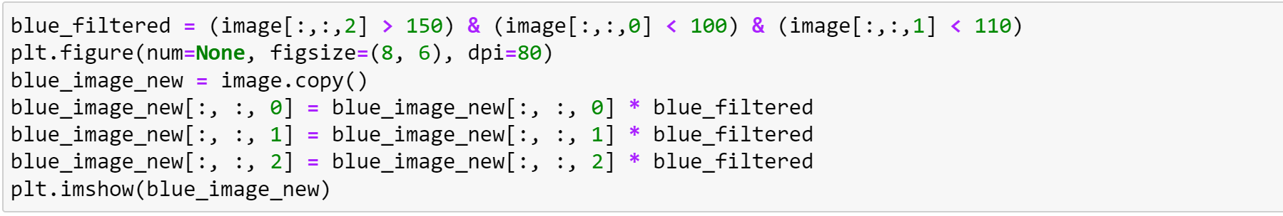

**Output:**

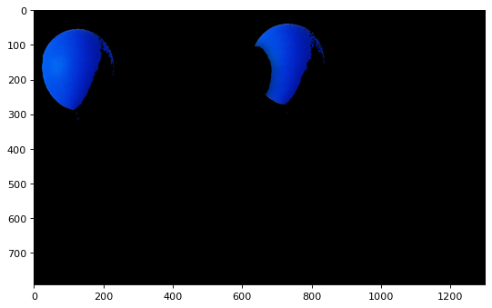

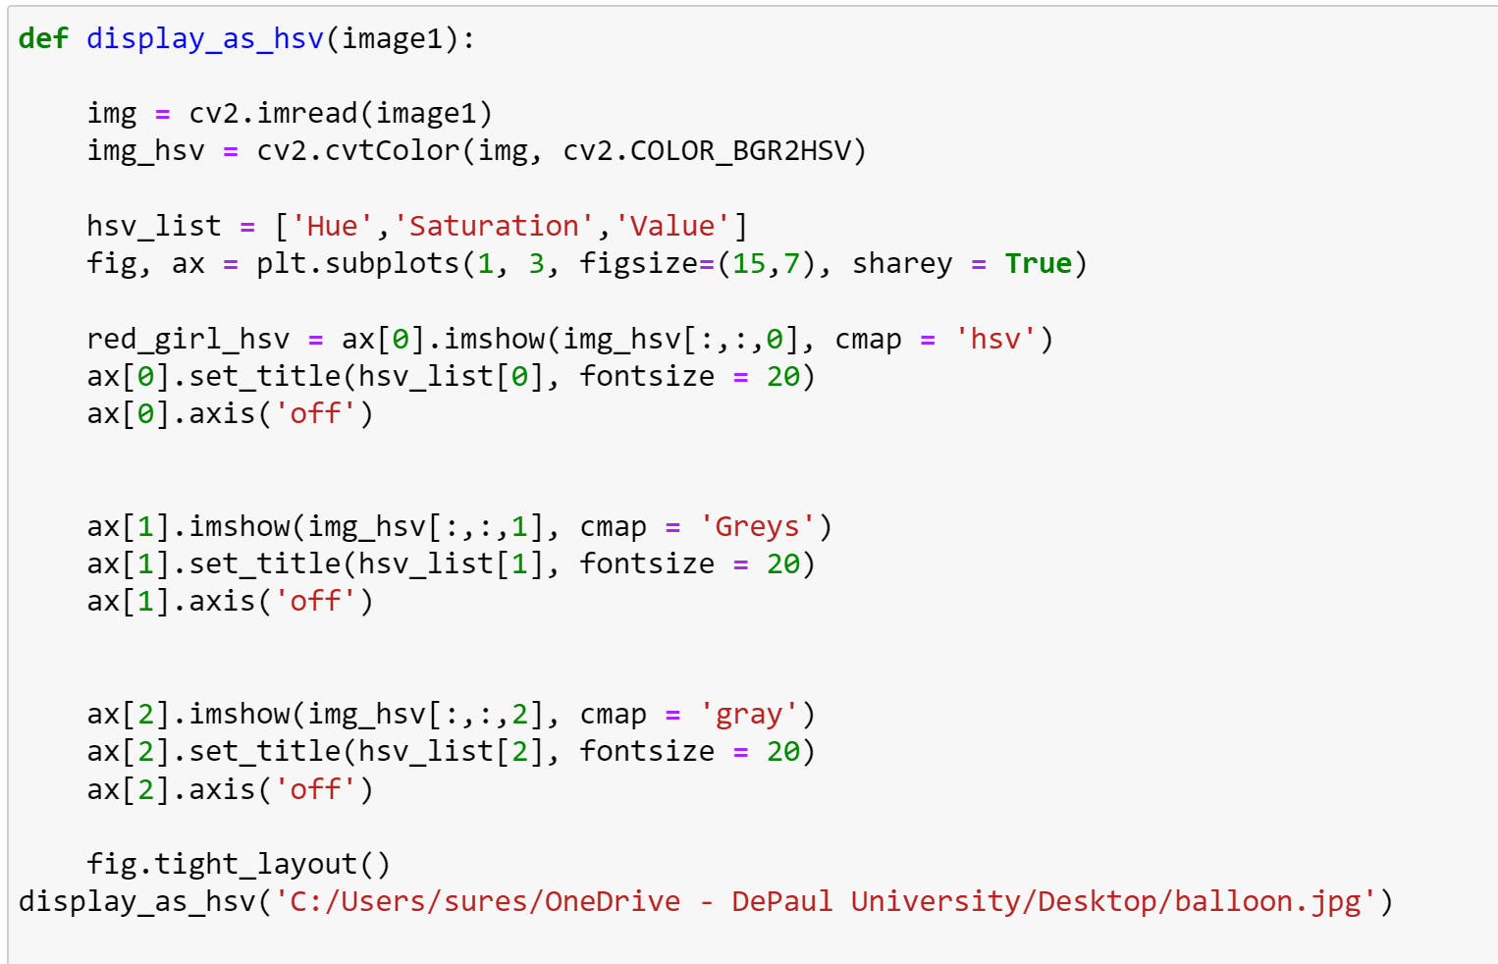

**Output:**

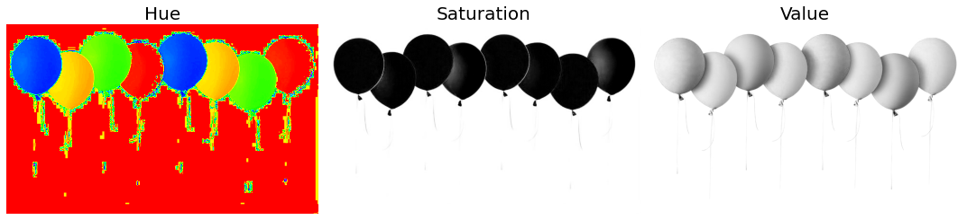

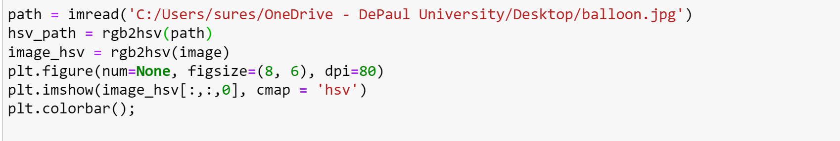

**Output:**

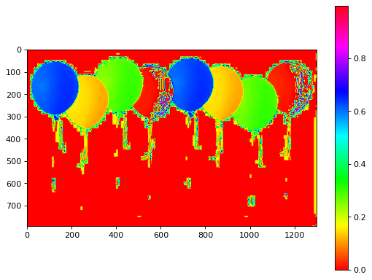

**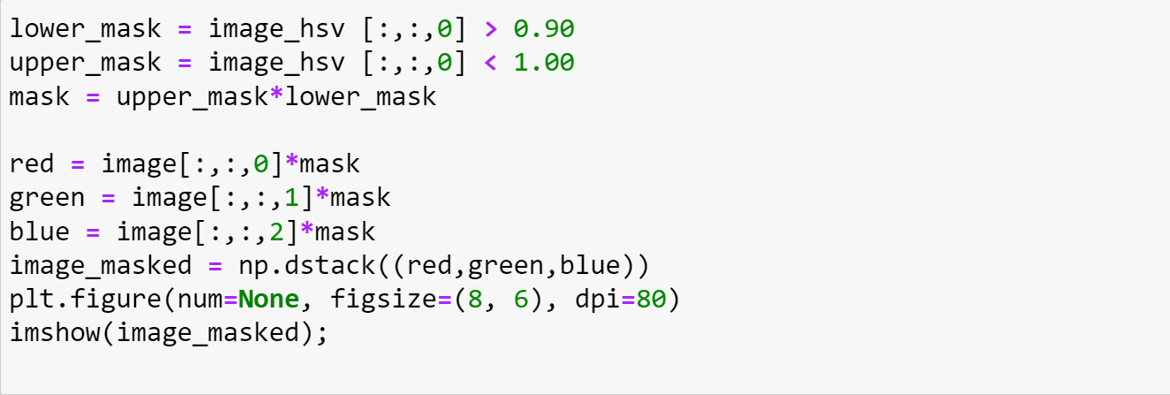  
Output:**

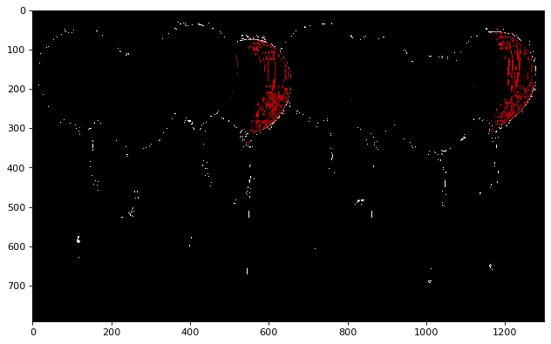

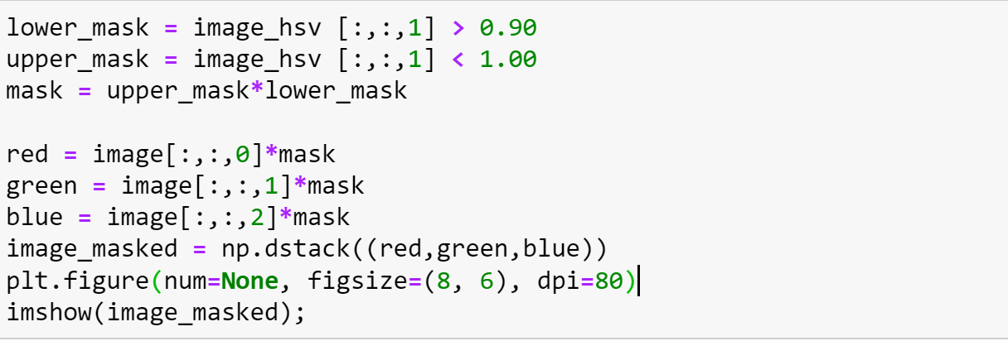

**Output:**

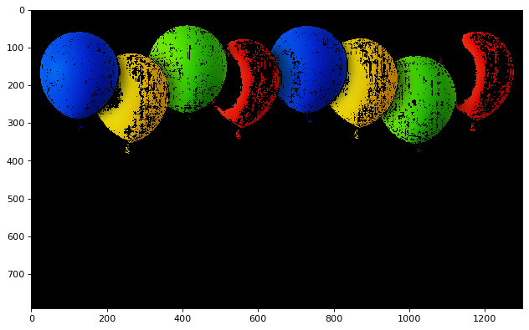

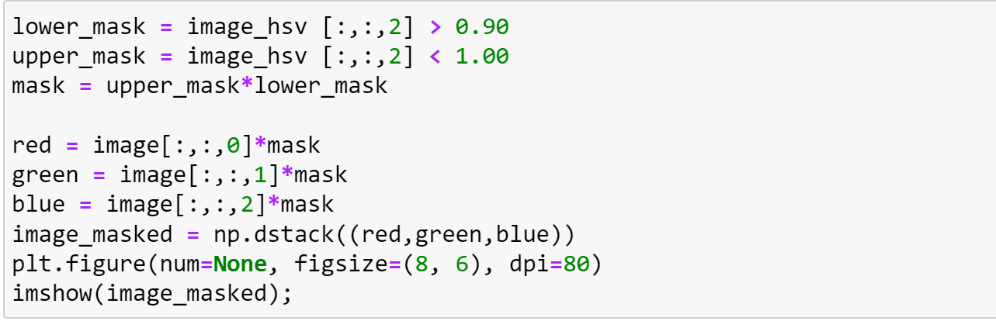

**Output:**

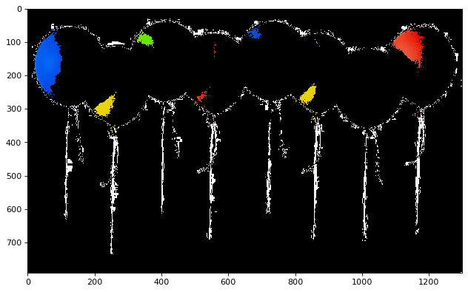

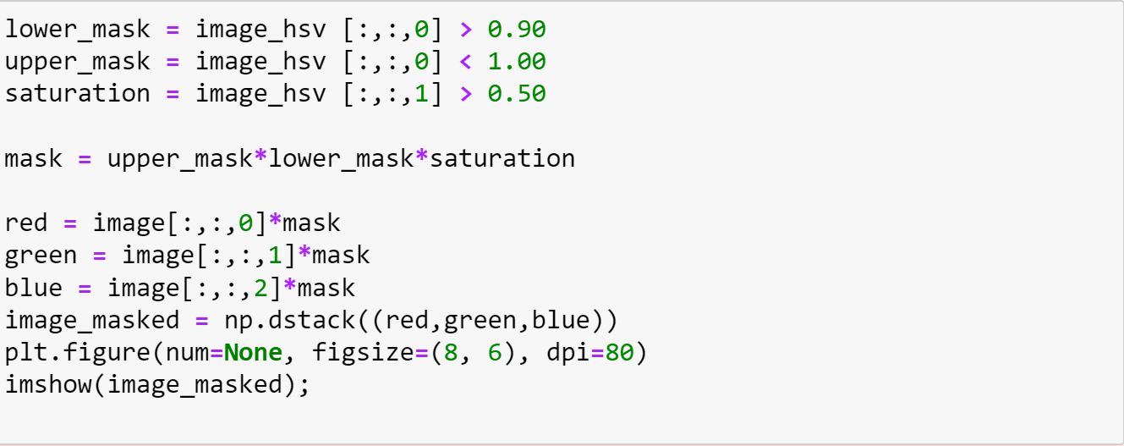

**Output:**

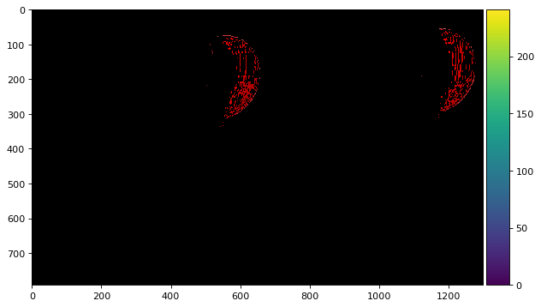

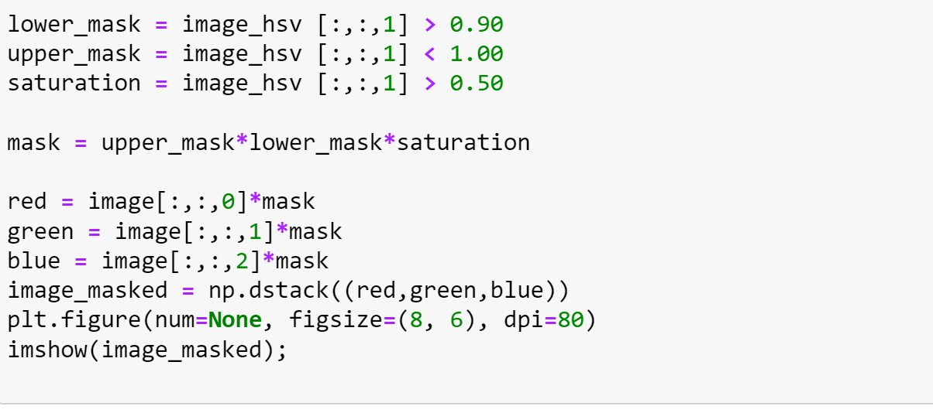

**Output:**



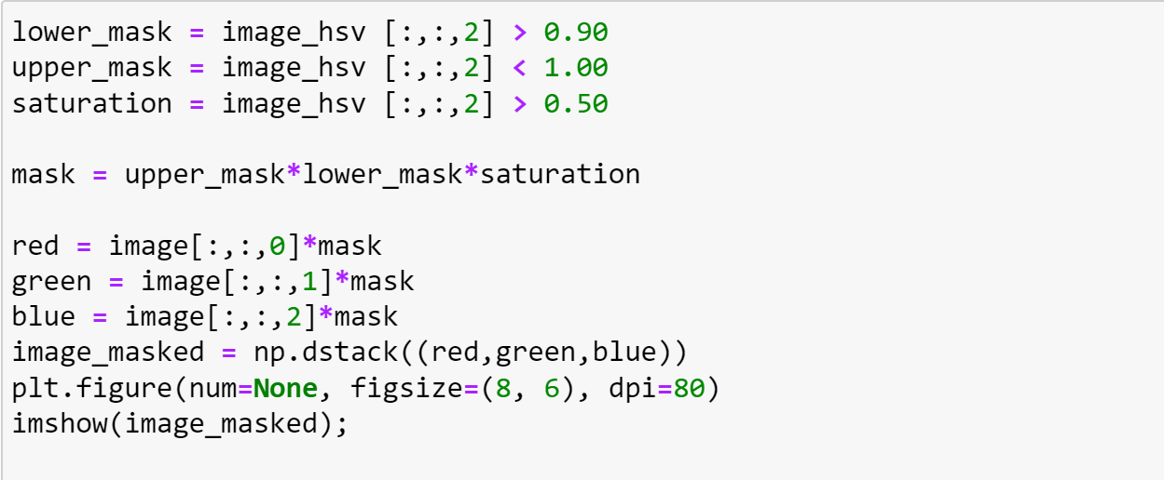

**Output:**

